DESIGN AND ANALYSIS OF ALGORITHMS
(23CSE211)

LAB-2

NAME: LOHITH BEJUGAM
ROLL.NO: CH.SC.U4CSE24204
SECTION: CSE-C
BUBBLE SORT
CODE:
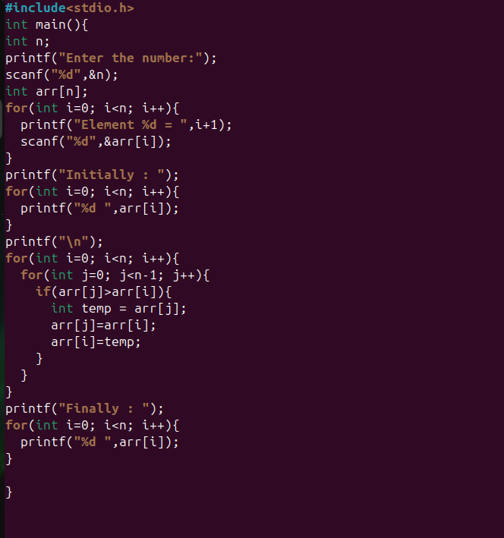
Output:
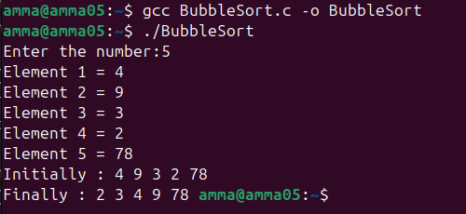
SELECTION SORT
Code:
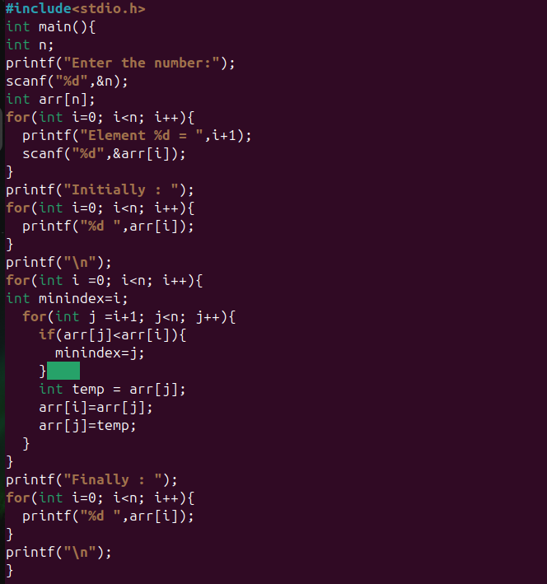

OUTPUT:
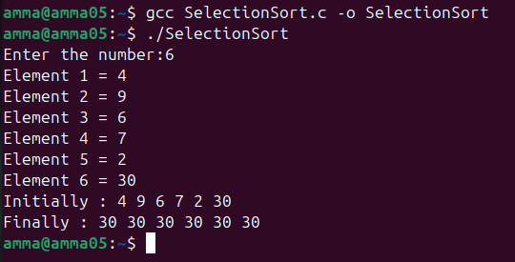

INSERTION SORT:
Code:
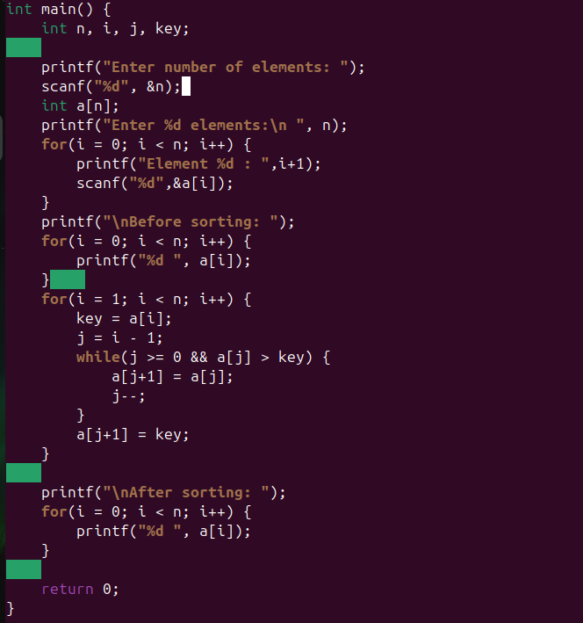

Output:
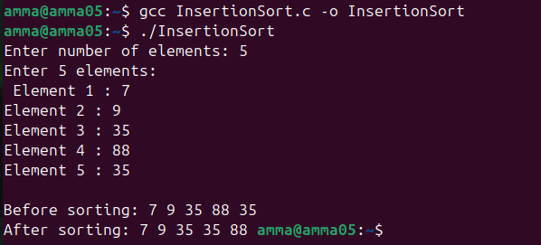

BUCKET SORT
CODE:
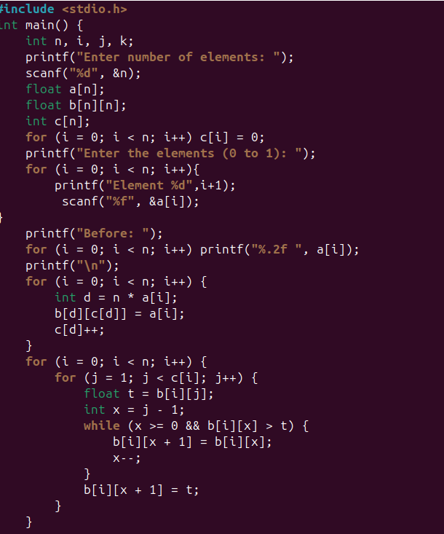
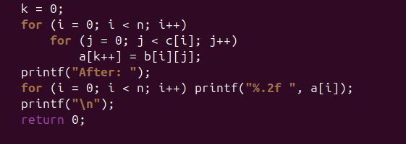
OUTPUT:
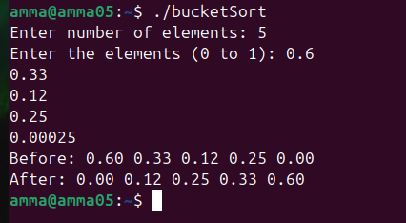

HEAP SORT
CODE:
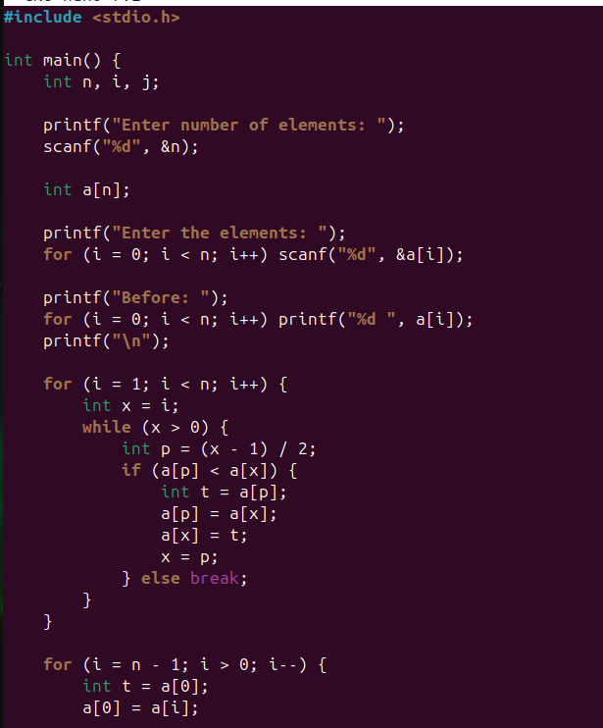
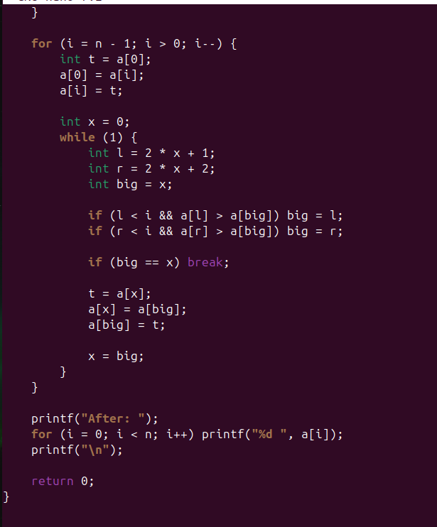
OUTPUT:
